**TESTING**

After finishing the part of coding, the next phase will be testing. In this task the code will be tested for ensuring whether the software is working properly or not also to identify whether the software is bug free or not. For the quality test of the software each and every code is tested and handled to clients.

In this task I have done unit testing and black box testing.

**Unit testing**

In this method of testing every single function of code has been tested to ensure that whether the code is working properly or not. The goal is to give the clients the perfect software.

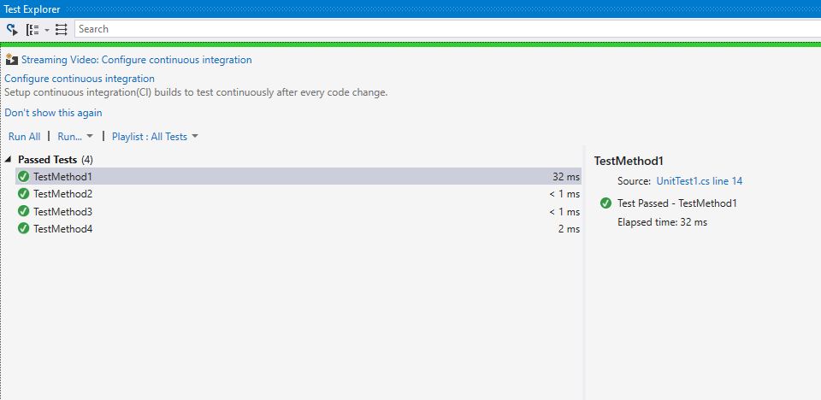

**Blackbox Testing**

In this method of testing is to test the interface part to test the accuracy. It tests the functionality without any interpretation with the implementation of internal. The main goal of this to know that what software is capable of what the software will do or not.

First test: registration form

Second test: login form

**Maintenance**

In this phase of SDLC the maintenance process of software will go on. In this task maintenance of software will be the upgrades of the software, repair of the software if any problem occurs in software than it will be fixed in this process. It is to much important for upgrading the software so while upgrading different types of problem will occur than if it occurs it will be repaired in this task. Monitoring is also part of the maintenance.

* **Other project issue**

1. **RISK MANAGEMENT**

**risk management is the main process of analyzing the danger, accessing and for overcome the threat to a company. It helps the company to run in a smooth way in future and helps the company to reach their goal.**

1. Problems and issue:

**Estimation has gone wrong**

When I about to do this project, every estimation has gone totally wrong on every aspect. Due to incorrect estimation the some of task have gone in improper way.

**Time has been short**

Due to short time of the project it will be very difficult to complete the task in time if the time has given us more than the project will be very fine.

**Health issue**

Due to season change I felt sick many time due to that all the features will not be implemented but however I have done this anyway and complete this project.

**Function is missing**

Some of the function is missing of the project which I have said in the proposal due to lack of time and my health condition.

**Limitation of The Project**

Everyone wants their software have high in functionality but due to some problems the projects have limitation and some of the limitation of this projects are mentioned below:

* The software is lack of security
* The software is not scalable
* Paddle should not choose

**Work of Future**

In future I have to add numerous functions in my software which will be updated in the next phase. It will look more better and attractive and also have more function due to that I will have best performance. In the future the things which I will add in this project are mentioned below:

* Bat option should be available
* Security will more increased
* Events will be organized
* Graphics will be increased
* Players have option to play in online and post their score online

**Conclusion**

finally, I would like to conclude that ping pong game has been successfully build to fulfill the aims and the goals which I have mentioned in the proposal. Due to some problem I have not add some of the features which I have said in the proposal.